

OppAttune Democracy Co-Lab

Care Democracy & Rising to the Challenge of Everyday Extremism Report

Authors: Dr. Zona Zarić and Dr. Sandra Obradović

Care Democracy & Rising to the Challenge of Everyday Extremism

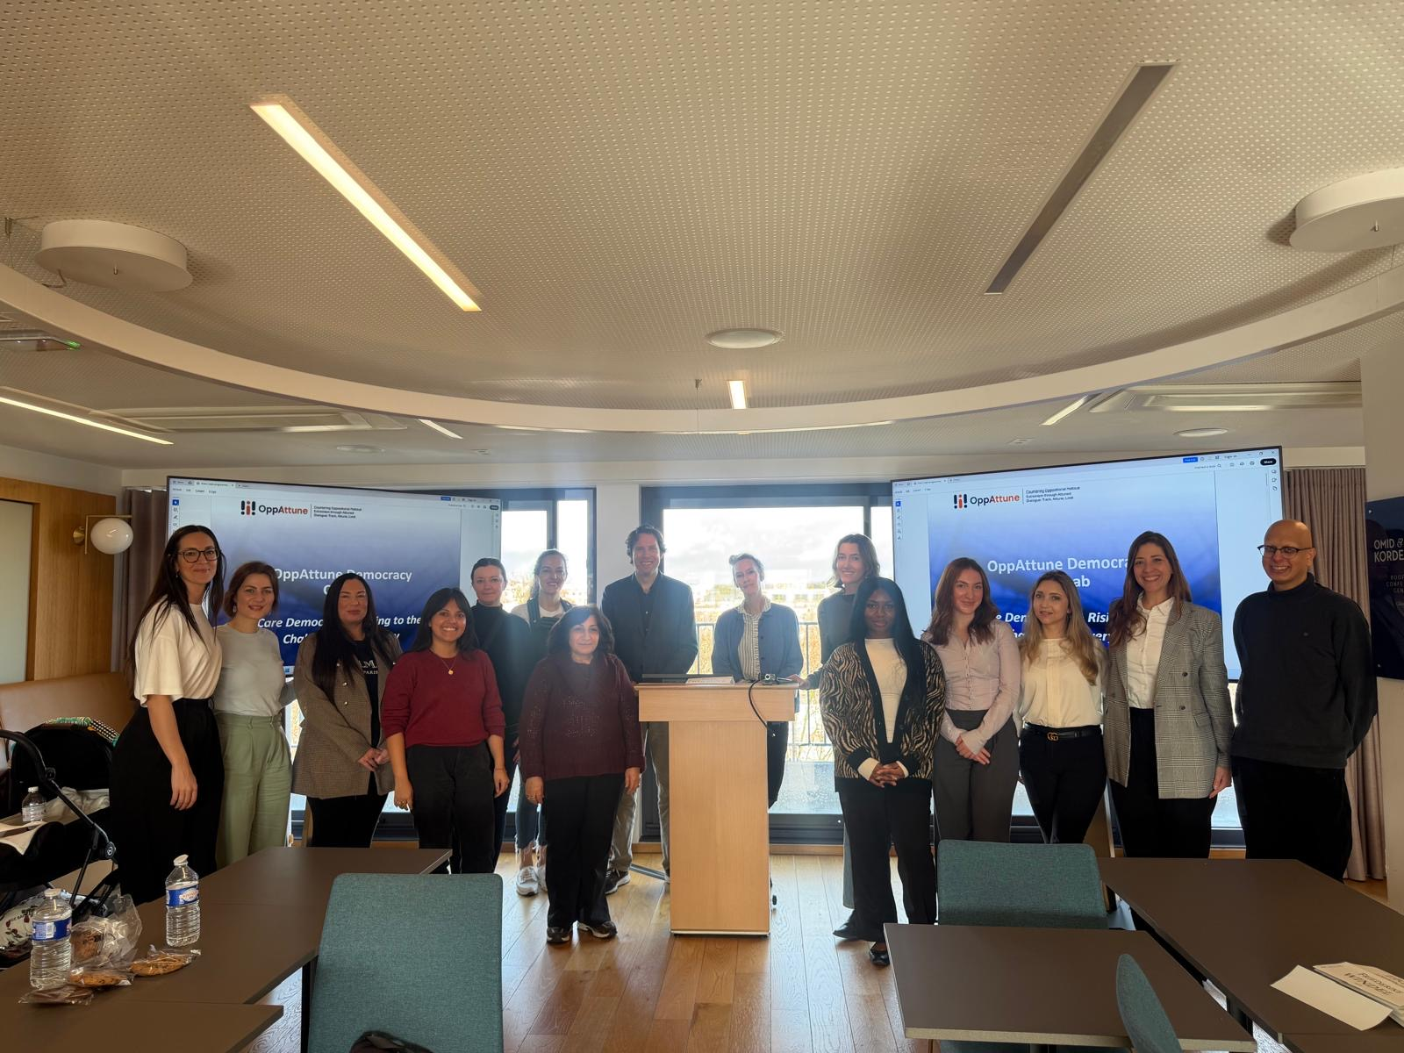
Over the course of a two-day collaboration convened within the framework of the OppAttune project and hosted in collaboration with the Center for Critical Democracy Studies (CCDS) and The Open University (OU), participants from philosophy, political theory, sociology, care ethics, media studies, and related fields engaged in a sustained collective inquiry into the contemporary transformations of democratic life. The event brought together an interdisciplinary community of researchers concerned with the entanglement of narrative, affect, and political subjectivation under current conditions of democratic fragilization.
Rather than focusing on institutional breakdown alone, discussions were structured around a shared hypothesis: that the corrosion of democracy today operates less through explicit ideological confrontation than through the diffuse and cumulative effects of what the project terms “silent narratives.” These narratives, circulating across media ecosystems and everyday interactions, contribute to the gradual reconfiguration of the boundaries of the sayable, the thinkable, and the politically legitimate.

1. From Ideology to Narrative: Reframing Democratic Erosion

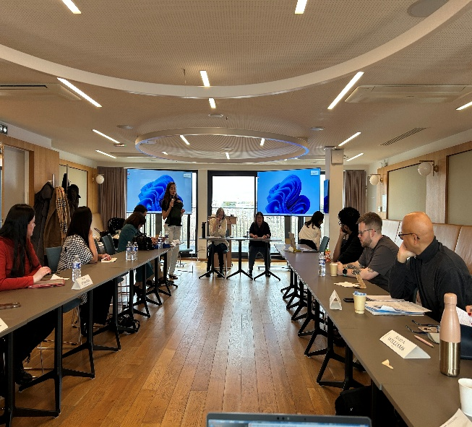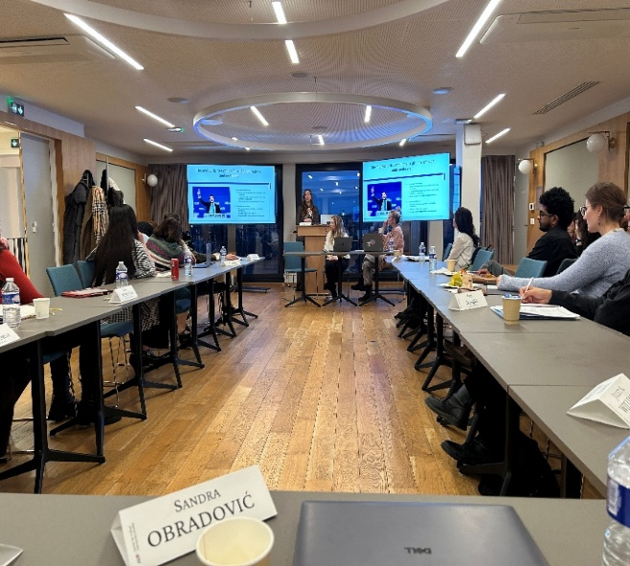
A first major line of convergence concerned the need to move beyond classical models of ideology centered on doctrinal coherence or state apparatuses, toward a more granular analysis of narrative infrastructures. Participants emphasized that contemporary forms of extremism rarely present themselves as systematic worldviews. Instead, they take the form of fragmented, iterative, and affectively charged micro-discourses: jokes, memes, conversational tropes, and seemingly innocuous framings.
These “low-intensity” discursive forms were analyzed as vehicles of normalization, capable of sedimenting exclusionary or hostile orientations without requiring explicit adherence. In this sense, the notion of everyday extremism was collectively refined: not as a deviation from democratic norms, but as a process internal to their gradual transformation.
Several contributions highlighted how such narratives operate through ambiguity and deniability, allowing them to circulate across heterogeneous publics while avoiding direct contestation. This raises a methodological challenge for the social sciences: how to capture phenomena that are distributed, unstable, and often resistant to formalization, yet politically consequential.

2. The Re-coding of Care and Democracy
A second axis of discussion focused on the discursive and affective re-signification of care and democracy themselves. Building on the initial framing, participants examined how both concepts are increasingly subjected to processes of normative inversion.
Care, historically associated with interdependence, responsibility, and social reproduction, is recoded as weakness, inefficiency, or moral excess. Democracy, in turn, is reframed as procedural obstruction, elite manipulation, or collective irrationality. These re-articulations do not necessarily reject democratic values outright; rather, they displace their legitimacy by embedding them within narratives of decline, threat, or dysfunction.
Importantly, these transformations were not treated as purely discursive. They were situated within broader political-economic and institutional contexts, including austerity regimes, the crisis of representation, and the platformization of public discourse. The workshop thus underscored the need to articulate discursive analysis with structural conditions, avoiding both culturalist reduction and economic determinism.

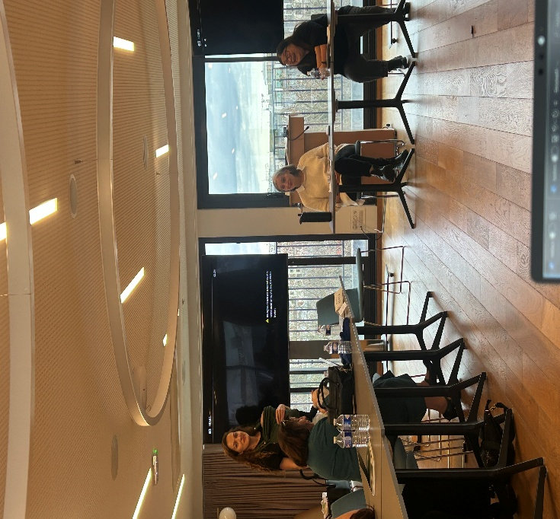
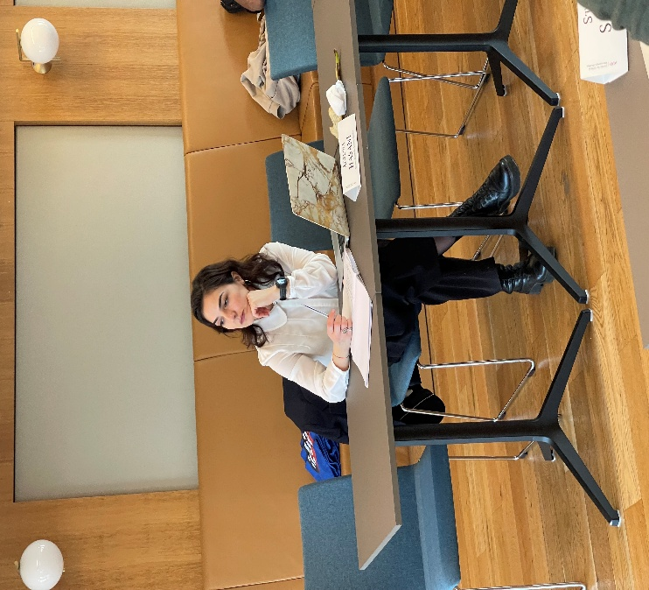
3. Anti-Gender Mobilizations and the Politics of Threat Construction
A significant portion of the discussions addressed the role of anti-gender mobilizations as a privileged site for observing the dynamics under investigation. Participants examined how feminist, LGBTQAI+, and reproductive rights are increasingly reframed under the umbrella of “gender ideology” or “woke,” terms that function as a floating signifier of threat.
This framing was analyzed as a powerful narrative device that condenses multiple anxieties about social change, national identity, and global governance, into a coherent but flexible antagonistic figure. In doing so, it contributes to the construction of a political imaginary in which solidarity appears as destabilization, and exclusion as protection.
Cross-national (Iraq, Sweden, India, France and Kosovo) perspectives highlighted both the circulation and contextual adaptation of these narratives, pointing to the importance of studying their trajectories across different political and cultural settings. The notion of transversal narrative ecologies emerged as a promising analytical lens for capturing these dynamics.

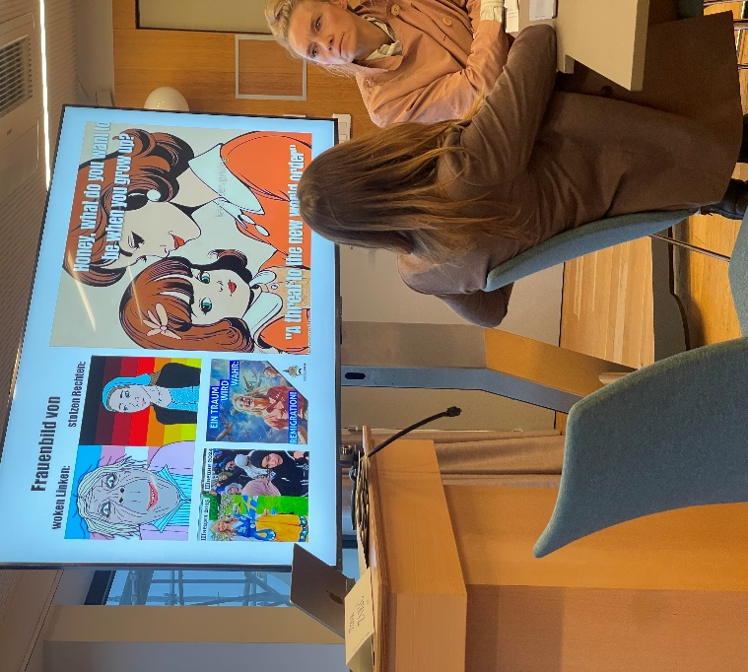
4. Methodological and Theoretical Implications
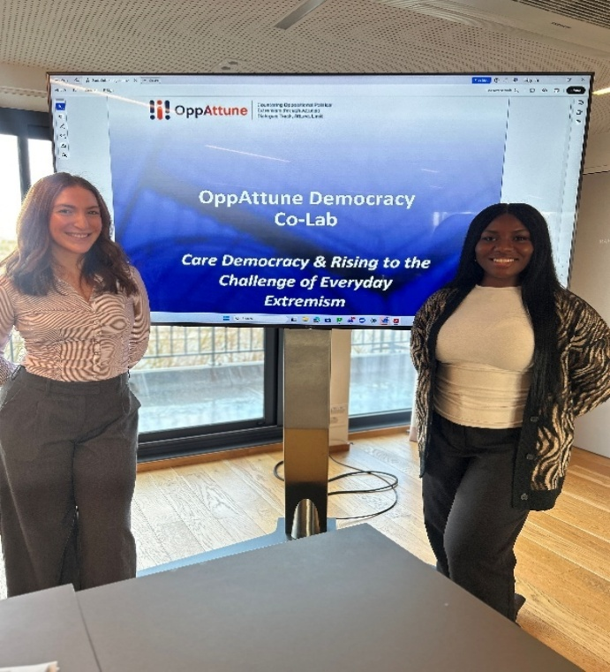
Beyond thematic discussions, the workshop generated a set of shared methodological concerns. Participants converged on the need for:
- Multi-scalar approaches, capable of linking micro-level discursive practices to macro-level transformations of political order;
- Interdisciplinary collaboration, integrating insights from philosophy, sociology, discourse analysis, and care ethics;
- New tools for analyzing affective and narrative circulation, particularly in digitally mediated environments.
The absence of stable or centralized sources of authority in the production of these narratives complicates traditional models of critique. As a result, several contributions explored alternative conceptual frameworks, including political subjectivation, “common sense” formation, and hegemonic recomposition.

5. Toward a Research and Publication Agenda
While the workshop was not designed to produce immediate consensus, it succeeded in delineating a shared research horizon. Participants identified several lines of inquiry that will inform future collaborative outputs, including:
- The conceptual clarification of silent narratives and everyday extremism;
- The analysis of the discursive construction of political legitimacy under conditions of democratic crisis;
- The role of care as both a normative and political category in resisting processes of democratic erosion;
- The mapping of transnational narrative circulations, particularly in relation to anti-gender movements.
These directions will be further developed through planned publications and continued collaboration within the OppAttune network and the CCDS and OU research communities.

6. Scientific and Societal Impact
From a Horizon Europe scientific impact perspective, the workshop contributes to advancing research on democratic resilience by shifting attention toward the pre-institutional and infra-discursive dimensions of democratic life. By identifying how legitimacy is gradually reconfigured through everyday narratives, the project opens new avenues for both analytical and normative intervention.
In terms of societal relevance, the findings underscore the importance of developing critical literacy toward narrative environments, as well as fostering forms of public engagement capable of re-articulating care and democracy as sources of collective strength rather than vulnerability.
If you would like to know more about OppAttune see:
Extremism Policy Brief
OppAttune-Countering-Oppositional-Political-Extremism-Through-Attuned-Dialogue-FINAL.pdf
Being political in divisive times | BPS
OppAttune | Countering Oppositional Political Extremism | Open University

